Inquiry and Teachable Moments
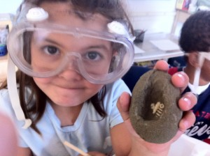
“See children as full of potential, competent and capable of building their own theories”. www.reggiokids.com
What is Inquiry-based Learning?
We absolutely love the above quote and feel that it encapsulates the whole idea of inquiry-based learning. Children already have the potential, they are already competent and capable of building their own theories about the world around them. They have been doing so since birth, first through listening, and watching, and mouthing everything around them and then through asking questions. Anyone who has ever had a three year old ask them why over and over and over again in a series of “why” questions knows that children naturally want to understand the world that they live in.
Inquiry-based learning means that we are honouring our children’s ability to drive their own learning. We are placing student questions and ideas at the centre of the learning process. Students are encouraged to ask questions and then investigate their own queries about the world. Inquiry-based learning is part of an emergent curriculum. It does not mean that the educators are relinquishing their role. It involves a different mindset, one where educators and students are co-learners, where educators are facilitators rather than dictators of the learning. There is a culture of collaboration. Educators use their knowledge of curriculum and expectations, and their expertise to extend learning. They ask open-ended questions and engage students in problem-solving processes. The educators document the learning as a process to take each child from where they are as a learner to where they need to go next.
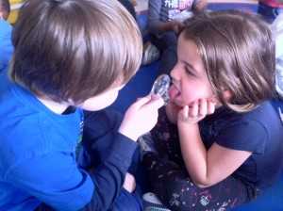

Opportunities are all Around
“Ordinary moments contain extraordinary moments of intelligence and strategic problem-solving strategies”. www.reggiokids.com

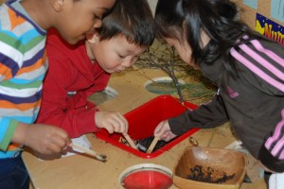
Wonderings about why so many worms were crawling on our playground during a very rainy day launched an inquiry into worms.
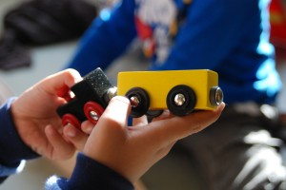
Wonderings about why sometimes the cars pulled together quickly and sometimes they pushed apart started an inquiry into magnets.

When educators are just getting started with Inquiry, they often ask how do you start an inquiry? Our response is always – Listen, listen, listen – not only with your ears but with your whole being. The students will let you know by their interest. If you are not sure, set out a provocation and see if you can engage them. The natural curiosity of young children makes them highly motivated learners.
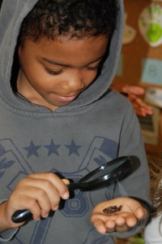
An Inquiry from a Provocation
We were thrilled to receive a gift of several honeycombs and nests of some sort from Dolores Cascone. Dolores had told us that these were not beehives and that we would have to find out what they were. We set them out and let the children explore. The children were convinced that these were honeycombs and bee hives but a quick look at bee hives on the internet let us know that Dolores was right. These nests were not from bees. We had to do a little bit of research to find out that these nests were the nests of paper wasps. We learned a little bit about paper wasps from the internet but most information about wasps leans towards how to dispose of the nests. Fortunately, the interest that was ignited by these nests and honeycombs was about to burn bright. We were about to go on a trip to Springridge Farm. What we didn’t know at the time is that they have an exhibit and presentation on the honey bee.
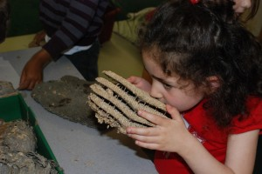

Researching wasps

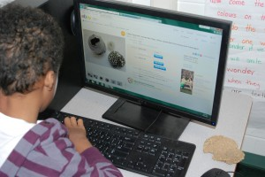

When Farmer Cameron showed the children the bee hives and the honeycombs the connection was made and they were hooked! We had something similar in our classroom!
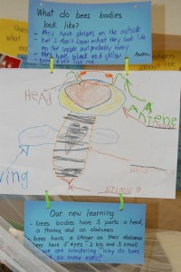
Back at school, we recorded all their questions and wonderings about bees. Then we all had a look at our wonderings. We had so, so many questions and ideas! To make it easier, we decided to group all the wonderings into categories. So with a bit of support, we came up with these categories – questions about the queen, the babies, honey, and the hive and how it differed from a wasp nest.
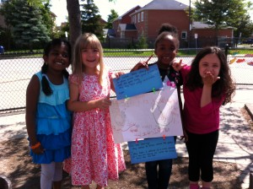
Next we worked in our small interest groups based on the categories we had created. Since we did all have some prior knowledge about bees and wasps, we recorded what we thought the answers to our own questions might be. (We want the children to know that ideas can change with new learning and that learning never stops.) Then we researched, recorded, and presented the new information to the larger group in various ways. We had diagrams, posters, sculptures, reports, and even dances for pollen collection that were danced to the Flight of the Bumblebee by Rimsky-Korsakov.
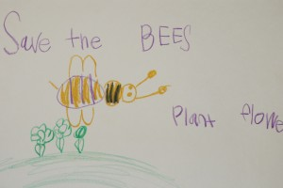
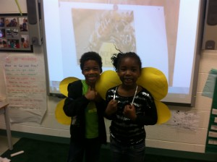
After we had shared our new learning we asked the students to consider – Why might it be important for farmers to keep bees on farms? To help feed us was the big answer but we kept probing and came up with the idea that farmers need the bees to help pollinate all the fruit and vegetable plants. As educators, we had done a little research of our own and shared with the children the unfortunate news that the bee population is dwindling. We discussed the implications this might have given that bees are the great pollinators and contributors to plant life. The fact that we had watched The Bee Movie of all things helped them to visualize what life on earth might be like without a strong bee population. The children came up with the idea that we could all plant more flowers to help the bees. We also decided that making posters would be a good way to inform others in our school about how to save the bees. We planted some sunflowers and in the fall, we are going to plant bulbs and perennials to help the bees too. We feel it’s important during an inquiry to make connections to the big picture of life.
A poster to encourage people to save the bees by planting flowers
Inquiry From Listening
Most of the time, the inquiry in our room comes from listening to what the children are saying and doing and asking about. A rainy day in early Spring, brought worms into our playground and spawned a deluge of questions about worms which resulted in an inquiry into worms. Each year as snails come out, we have lots of little visitors to our room and then inquiry into snails. Some other student-sparked inquiries have been about Space and the Planets, plant growth, roots, early Aboriginal life, dinosaurs, and the body just to name a few. It has been amazing what we, as educators, have learned from these inquiries. We had had no idea that worms have 5 hearts. As one little boy remarked – wow! Five hearts, worms sure have a lot of love!
The interest and motivation to learn through inquiry is motivating to us as educators as well as for the students. we are inspired and excited and love learning alongside our children.
An Inquiry within an Inquiry
Sometimes an inquiry can be short and come up unexpectedly. We want to share this with you just because it shows how intelligent these young people are and how they can build their own theories and make adjustments based on their new learning. The boys are four years old and have discovered the effect of friction on an object.
During an inquiry into plants and seeds, we found some of our boys using our cube blocks to spin. They were making us crazy. Little cubes stacked together, spinning all over the floor and hitting us in the ankles. On day two, we looked at one another – these cubes needed to go. But, they were so engaged and so excited! There must be some learning happening here. We decided to contain the spinning menaces and listen to the conversation closely. So… we put out 4 white trays on a table and told the boys that they could spin to their hearts content but only on the trays. We didn’t care how many students were at the table as long as they could manage cooperatively.
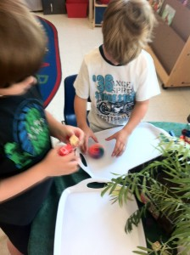
Then we listened.
They seemed to be engaging in a type of challenge.
Here is dialogue captured as the children explored and discovered spinning…
Educator: Wow, you guys are having an exciting contest.
Child 1: Yeah, it’s a battle you gotta try and win.
How do you know who wins?
Child 2: The one who goes fastest and longest.
Child 1: Yeah, whoever goes the longest is the winner.
Child 3: Yeah, you gotta battle everyone and never stop.
When I was watching you, I noticed that you were making changes to your – what are these called?
Child 3: They’re bey blades
Ok. So what kind of changes were you making to your bey blades?
Child 4: Watch, when you go like this (spins on flat side) it doesn’t spin very fast or go for long. But then you put this one on (puts other cube in middle) it spins really good.
Why do you think that happens?
Child 4: ‘Cause of the point. The point makes it go fast.
Hmm. So why do you think the point might make it go fast and this side makes it go slow?
Child 3: ‘cause this side (flat side) is sooo big and the point is little. This side has too much touching the tray
Aaah, so it goes slower when too much is touching the tray but faster when there’s only a little.
Child 3: Yeah. The trays really slippy but it still goes slow when its big.
Child 4: Yeah. It goes faster here than the floor.
Interesting. What do you think might happen if we tried them on the carpet?
There was lots of laughter and explanations about how they wouldn’t go because the carpet is – loopy, bumpy, lumpy and the best spinning surface is flat and slippery. Then we tried it. It didn’t work. But what it did do is pull more children into the inquiry. We tried a variety of surfaces and various adjustments to the amount of bey blade touching the surface, then we shared our findings at Sharing Time. This brought out all sorts of ideas – we could try pulling each other around the room on different surfaces – blankets, boxes, cushions… We could try sliding down the hill in the playground on different surfaces to see which go faster. We experimented with friction. And one quiet 4 year old had a remarkable connection. She said this reminded her of going down the slide in the summer and then in the cold weather. In cold weather she wore pants and slid quickly, in summer she wore shorts and stuck to the slide.
Here are some inquiry questions we have posted throughout our room. We use these to prompt higher order thinking in the children as we extend their learning and play. We post them as a cue for ourselves and others who may be visiting our room.
* “What might happen if you…”
* “What might you try instead?”
* “How do you think that could have happened?”
* “How do you know?”
* “What could you try differently?”
* “Show me what you can do with it?”
* “Tell me about your…”
For more information on inquiry, you may want to visit this site:
http://naturalcuriosity.ca/

